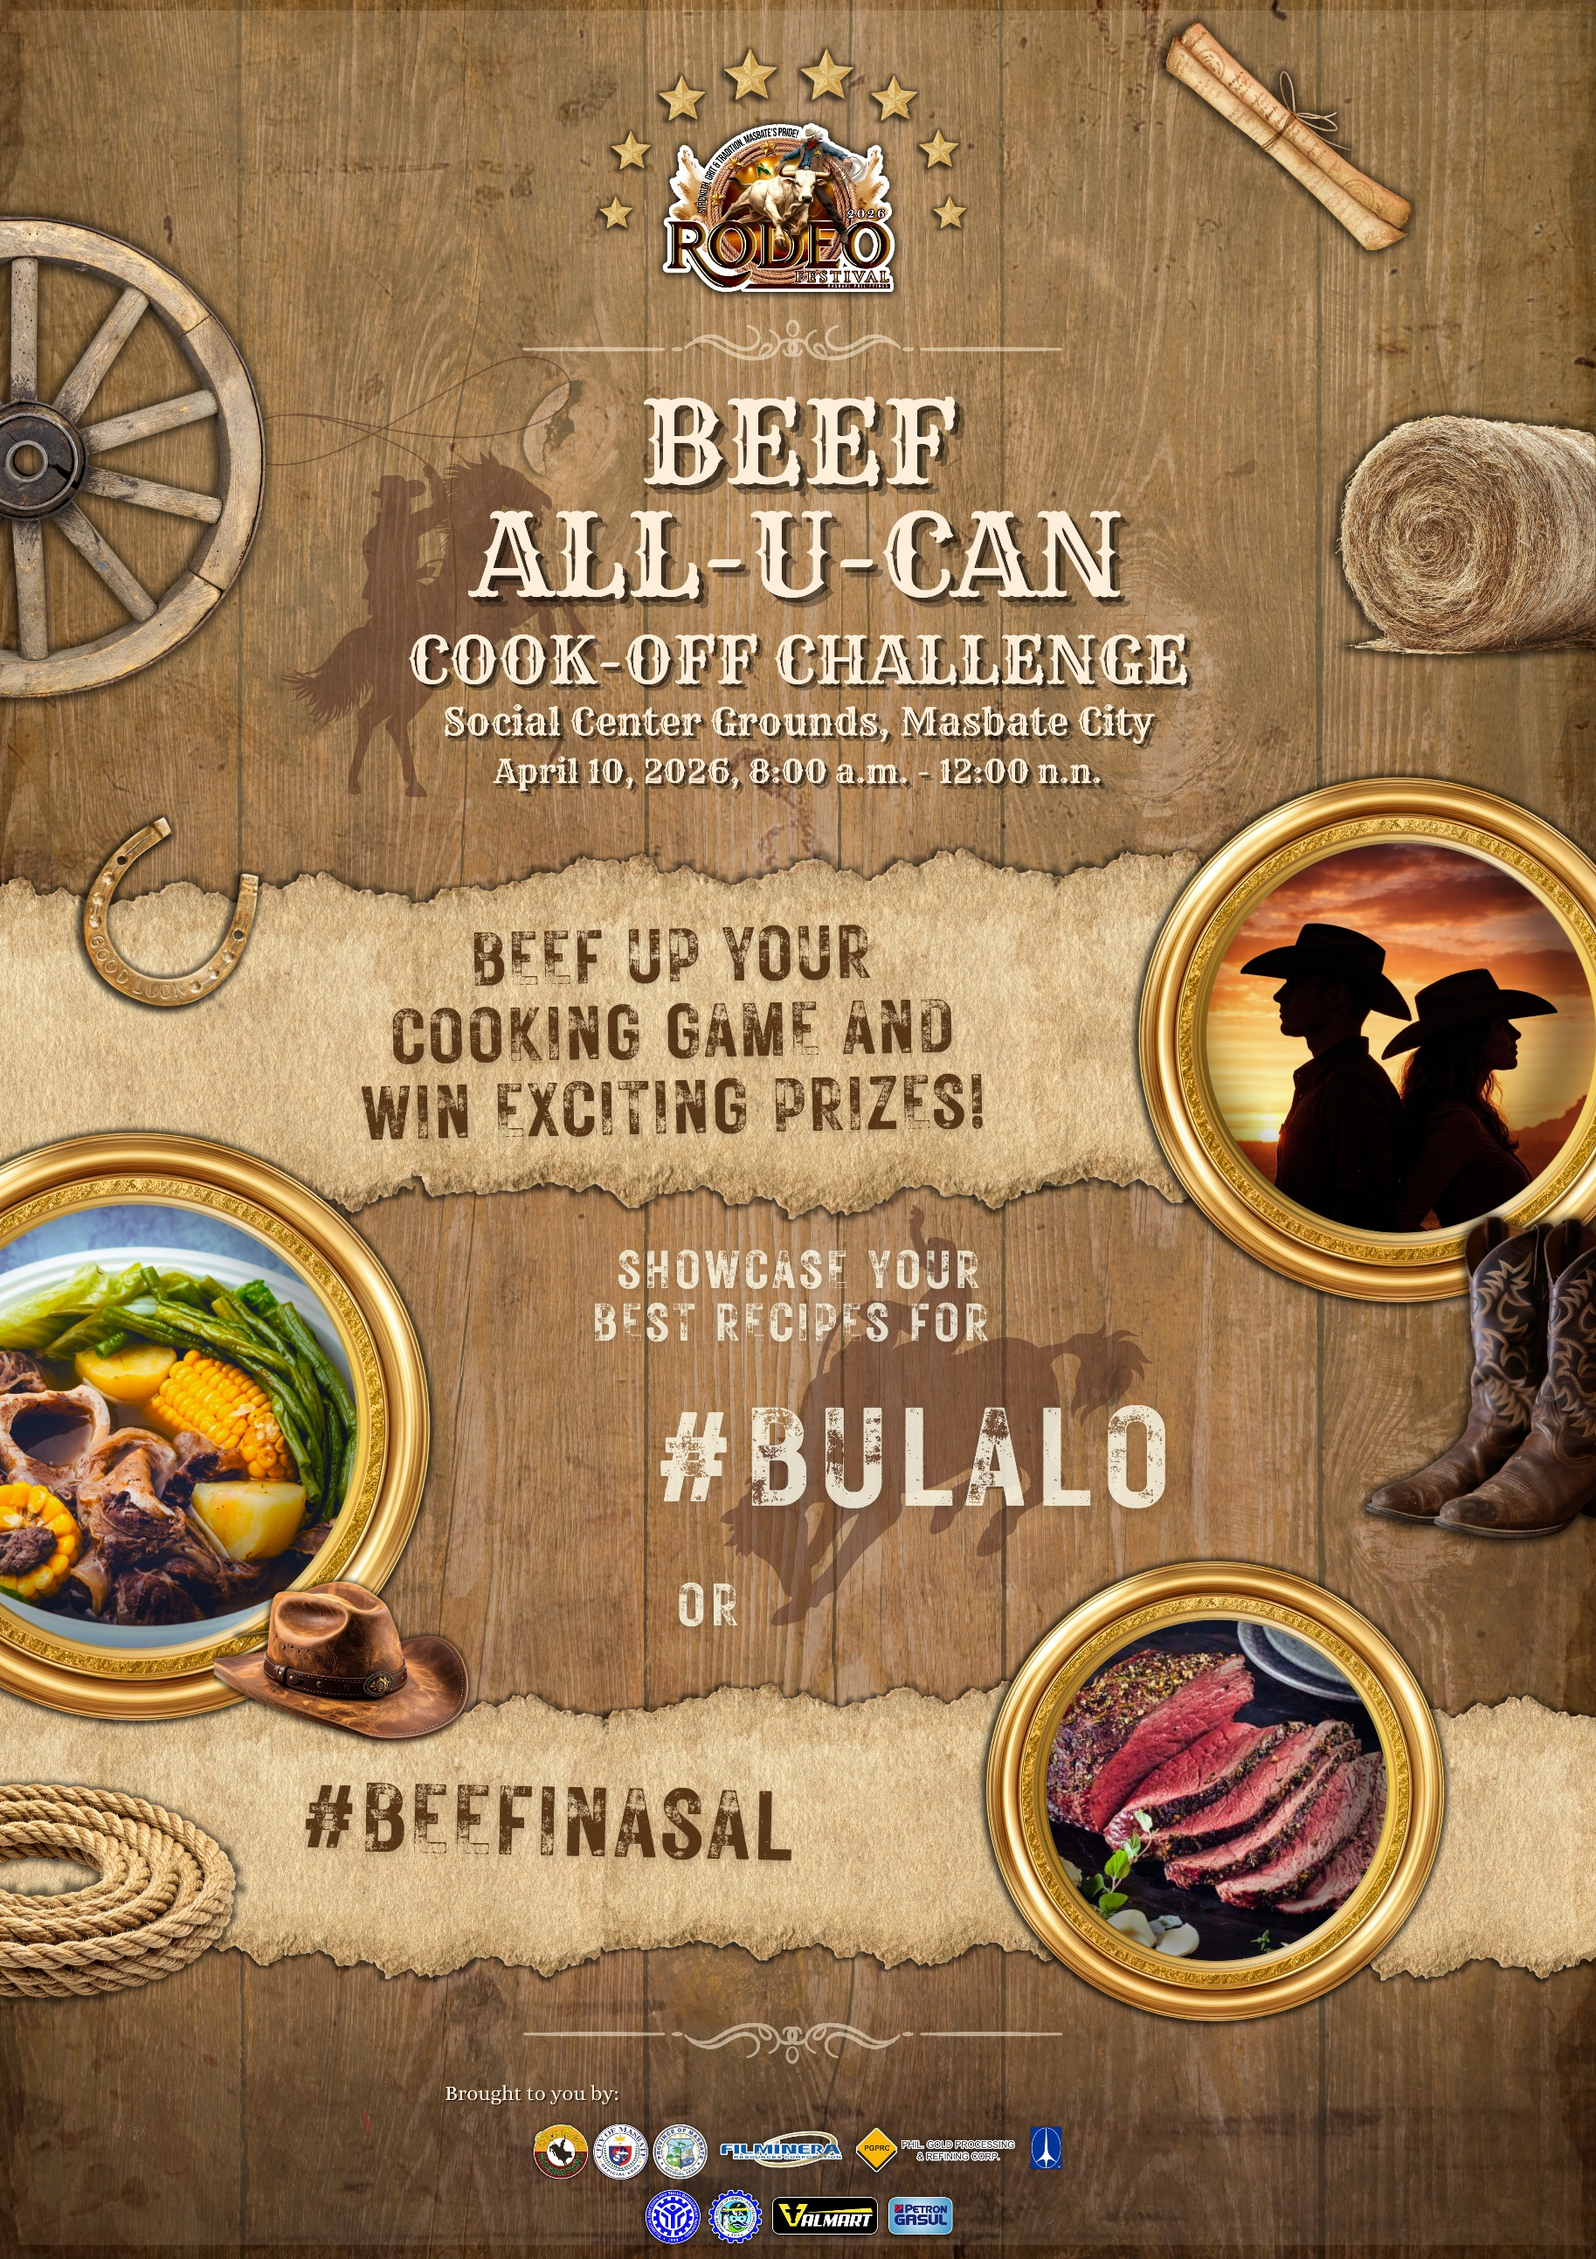

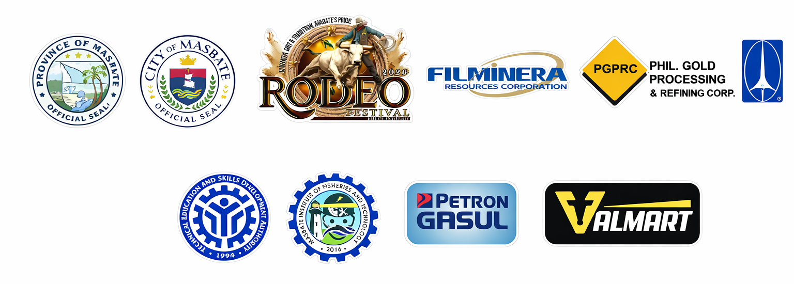

30th Rodeo Festival
2026 BEEF COOKING COMPETITION
“Showcasing Masbate’s Culinary Heritage”

Official Rules, Mechanics, Criteria for Judging, and Contestant Requirements

- OBJECTIVES

The 2026 Beef Cooking Competition is one of the major highlights of the 30th Rodeo Festival. It aims to:
- Promote beef as the premier agricultural product of Masbate.
- Showcase culinary excellence in preparing either Beef Bulalo or Beef Inasal.
- Preserve traditional cooking methods while encouraging responsible creativity.
- Promote food safety, sanitation, and professional culinary standards.
- Strengthen community participation and celebrate Masbate’s rich culinary heritage.
- Provide a platform for chefs, students, and local cooks to demonstrate their skills.

II. ELIGIBILITY
- The competition is open to:
  - Professional chefs
  - Culinary students
  - Amateur cooks
  - Local food entrepreneurs
- Participation may be:
  - Individual (1 cook), or
  - Team of two (1 cook and 1 assistant only)
- All contestants must:
  - Be at least 18 years old.
  - Submit complete registration requirements on or before the deadline.
  - Attend the mandatory pre-competition orientation and briefing.
  - Agree to abide by all official competition rules.

III. COMPETITION FORMAT

A. Dish Category (Contestant’s Choice)

Each contestant/team must choose and prepare ONLY ONE (1) of the following:
- Beef Bulalo
OR
- Beef Inasal

The chosen category must be declared upon registration and cannot be changed on the day of the competition.

IV. INGREDIENTS AND EQUIPMENT GUIDELINES

A. Beef Provision
The organizers will provide the official beef according to the chosen category:
- Beef shank (for Bulalo), OR
- Specified beef cut (for Inasal)

Guidelines:
- No substitution or replacement of the provided beef is allowed.
- Beef will be distributed during the official start of the competition.
- Contestants must inspect the beef before cooking begins.

B. Ingredients
Contestants are responsible for bringing all other ingredients, including:
- Vegetables
- Spices and seasonings
- Marinades
- Sauces
- Garnishes
- Accompaniments

Strictly Prohibited:
- Pre-cooked beef
- Pre-cooked broth (for Bulalo)
- Pre-grilled beef (for Inasal)
- Pre-prepared sauces or reductions
- Artificial flavor enhancers not declared in the ingredient list

All seasoning, and cooking must be done within the official competition time, however, due to time constraints, pre-marinated beef may be used.

C. Equipment

The organizers will provide ONLY:
- Gas tank
- Gas stove
- Preparation table

Contestants must bring:
- Knives and chopping boards
- Cooking pots or grill equipment
- Cooking utensils and tools
- Mixing bowls
- Plating materials
- Cleaning materials (cloths, trash bags, etc.)
Electrical appliances are discouraged unless previously approved.

V. COOKING TIME AND FLOW
- 15 minutes – Station setup and preparation
- 2 hours – Cooking proper
- 5 minutes – Final plating
Guidelines:
- All cooking must stop immediately when time is called.
- Plating must be completed within the allotted time.
- Late submission will incur penalties.

VI. PORTION REQUIREMENTS
Each contestant/team must prepare:
- Three (3) plated servings for judges; and
- One (1) display plate for documentation and exhibit.
Portions must be equal in size and presentation.

VII. FOOD SAFETY, SANITATION & PROFESSIONAL CONDUCT
Strict compliance is required.

Required Attire:
- Chef jacket or proper uniform
- Apron
- Hairnet or chef hat
- Closed, non-slip shoes

Hygiene Rules:
- No jewelry during cooking
- Clean fingernails (no nail polish)
- Frequent and proper handwashing
- Proper waste segregation and disposal
- Raw and cooked food must be handled separately

Unprofessional behavior, unsafe food handling, or unsportsmanlike conduct may result in deduction or disqualification.

VIII. CRITERIA FOR JUDGING (100%)

Criteria | Percentage
Taste & Flavor Balance | 40%
Authenticity & Cooking Technique | 25%
Doneness & Texture of Beef | 20%
Presentation & Plating | 10%
Hygiene & Work Organization | 5%
TOTAL | 100%

Detailed Description of Criteria
1. Taste & Flavor Balance (40%)
- Depth and richness of broth (Bulalo)
- Balanced seasoning and marinade penetration (Inasal)
- Harmony of flavors
- Overall deliciousness

2. Authenticity & Cooking Technique (25%)
- Proper simmering and broth clarity (Bulalo)
- Proper grilling method and basting technique (Inasal)
- Respect for traditional preparation methods

3. Doneness & Texture of Beef (20%)
- Tenderness and juiciness
- Proper cooking temperature
- Consistency of texture

4. Presentation & Plating (10%)
- Clean and attractive presentation
- Proper garnish
- Appropriate serving portion

5. Hygiene & Work Organization (5%)
- Clean workstation
- Proper handling of ingredients
- Organized workflow

IX. SCORING AND TIE-BREAKER RULES
- Each judge will score independently.
- Scores will be tabulated by the Technical Committee.
- The highest total score wins.

In case of a tie:
- Higher score in Taste & Flavor Balance prevails.
- If still tied, higher score in Authenticity & Technique prevails.
- Judges deliberate for final decision.
The decision of the Board of Judges is FINAL and IRREVOCABLE.

X. DEDUCTIONS
Violation | Deduction
1–5 minutes late submission | -5 points
6–10 minutes late | -10 points
Beyond 10 minutes | Disqualification
Minor unsanitary practice | -1 to -5 points
Major sanitation violation | Disqualification
Use of prohibited pre-prepared ingredients | Disqualification

XI. REQUIRED DOCUMENTS

All contestants must submit:
- Accomplished registration form
- Photocopy of valid ID
- Signed waiver
- Complete ingredient list
- Declared chosen category (Bulalo or Beef Inasal)
Incomplete documents may result in disqualification.

XII. DECLARATION AND AWARDS

BEEF BULAO
- Champion – Cash Prize of P15,000.00 and Certificate
- 1st Runner-Up – Cash Prize of P10,000.00 and Certificate
- 2nd Runner-Up – Cash Prize of P5,000.00 and Certificate
- Consolation Prizes for non-winners

BEEF INASAL
- Champion – Cash Prize of P15,000.00 and Certificate
- 1st Runner-Up – Cash Prize of P10,000.00 and Certificate
- 2nd Runner-Up – Cash Prize of P5,000.00 and Certificate
- Consolation Prizes for non-winners

Special Awards:
- Best Beef Bulalo
- Best Beef Inasal
- Best in Presentation
- Best in Hygiene

XIII. DISQUALIFICATION GROUNDS
A contestant may be disqualified for:
- Changing declared category
- Using substitute beef
- Receiving outside assistance
- Violating sanitation rules
- Unsportsmanlike conduct
- Failure to complete the dish within time

